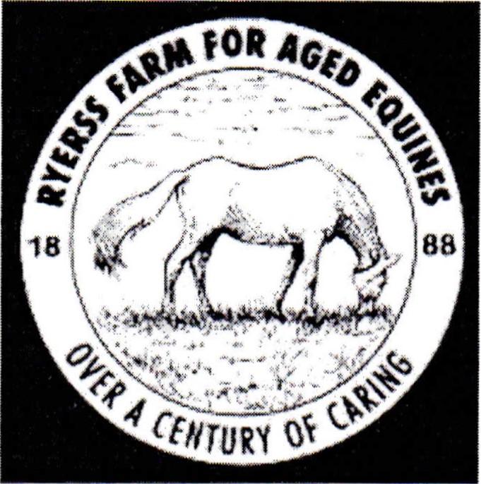
Photo/Video Release Form

AUTHORIZA TION TO USE PHOTOGRAPHS AND/OR AUDIO-VISUAL
l, hereby authorize persons associated with Ryerss Farm for Aged Equines to use, reproduce, and/or publish photographs and/or video that may pertain to me or my minor children— including image, likeness and/or voice without compensation.
I understand that this material may be used in various publications, public affairs releases, recruitment materials, broadcast public service advertising (PSAs) or for other related endeavors. This material may also appear on Ryerss Farm for Aged Equines Internet Web and/or Facebook page.
This authorization is continuous and may only be withdrawn by my specific rescission of this authorization. Consequently, Ryerss Farm for Aged Equines may publish materials, use my/child's name, photograph, and/or make reference to me/child in any manner that Ryerss Farm for Aged Equines deems appropriate in order to promote/publicize service opportunities and/or recent events.

Signature/Parent Signature of minor child

Date

